**th** **Clone**

1. **(a)Home Page //**

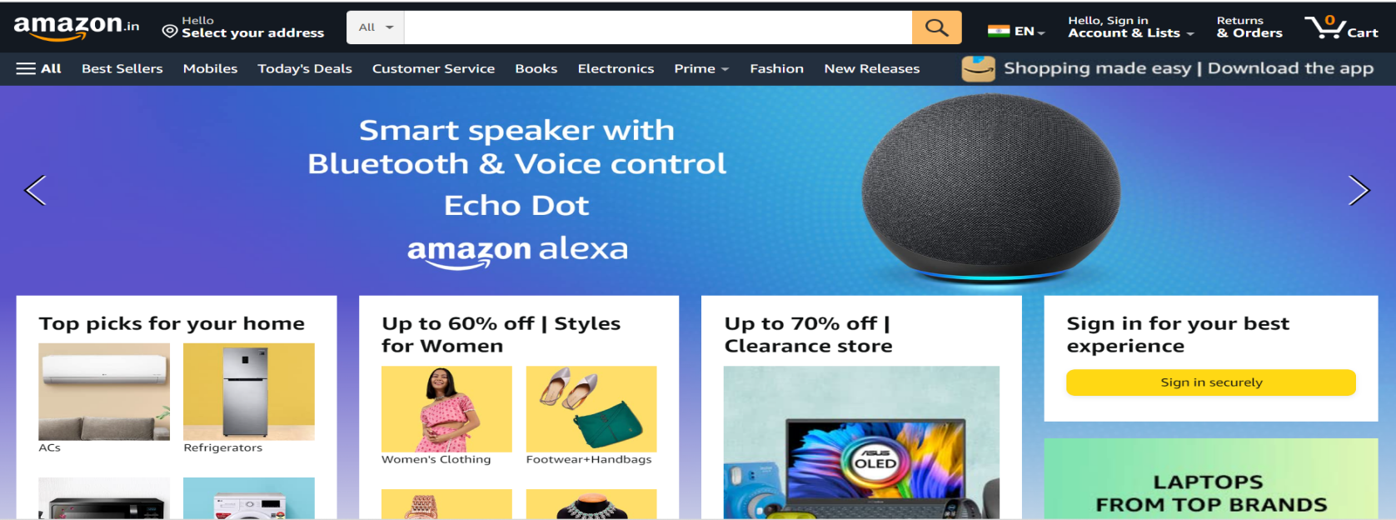

* **Logo**
* **Search Bar**
* **Icons : Location/address;**

**Select country;**

**Wishlist;**

**Add to cart;**

**Hamburger icon**

* **Options : Hello;**

**sign-in;**

**Return & orders**

* **Extra Options : Bestsellers;**

**Today’s Deals;**

**Customers Service;**

**New releases**

* **Sliders with arrows : Trending images;**

**Advertisements**

* **Mapped and Linked Image catagories : Deals;**

**Tap to explore;**

**Trending products;**

**Books;**

**Home & electronics;**

**Home&kitchen;**

**Daily essentials;**

**Baby Products;**

**Beauty Products;**

**Sports & Fitness;**

**Grocery & Gourmet**

**1.(b)Footer of Home Page //**

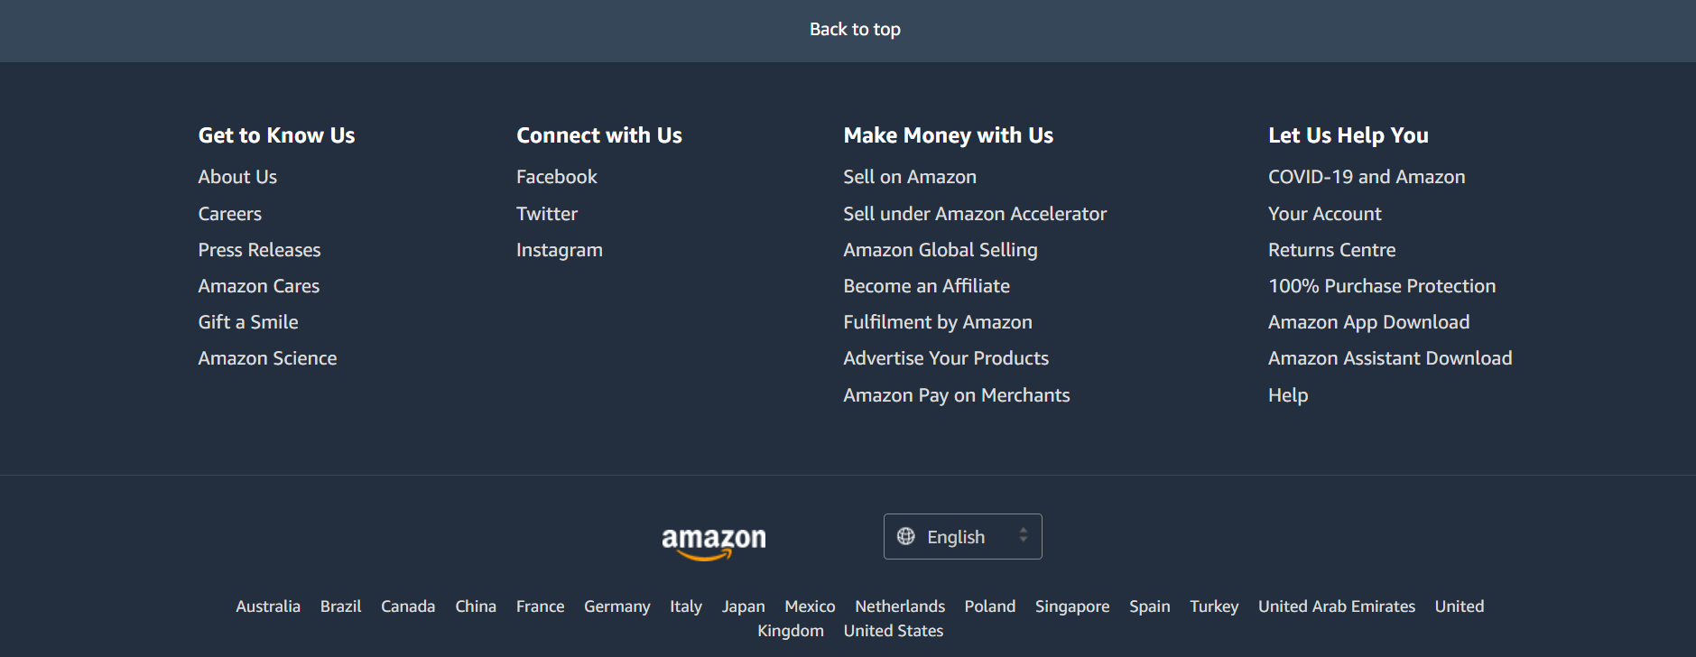

* **Back to top (same page link)**
* **Get to Know Us**
* **Connect with Us**
* **Make Money with Us**
* **Let Us Help You**
* **Logo( at the bottom)**
* **Language select option**
* **List of countries using Amazon**

**2.Sign-in or New Account log in //**

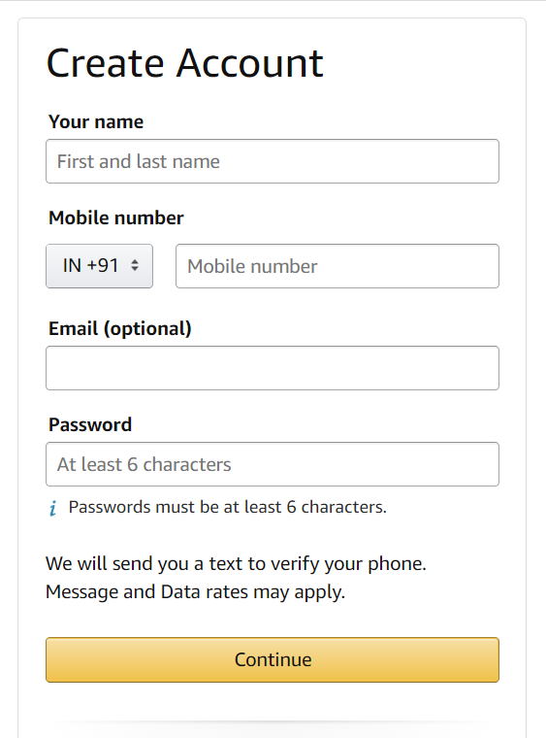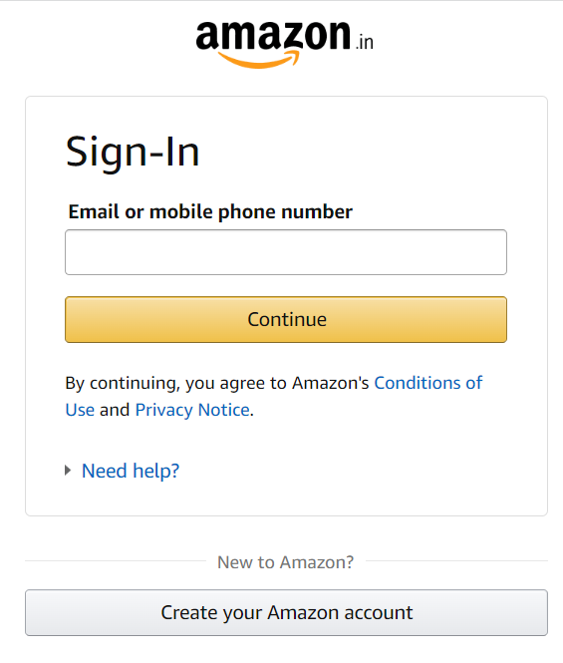

**Or**

* **Phone Number or**
* **Email address**
* **A link page from sign-in page to create new account page**

**3.Product Page //**

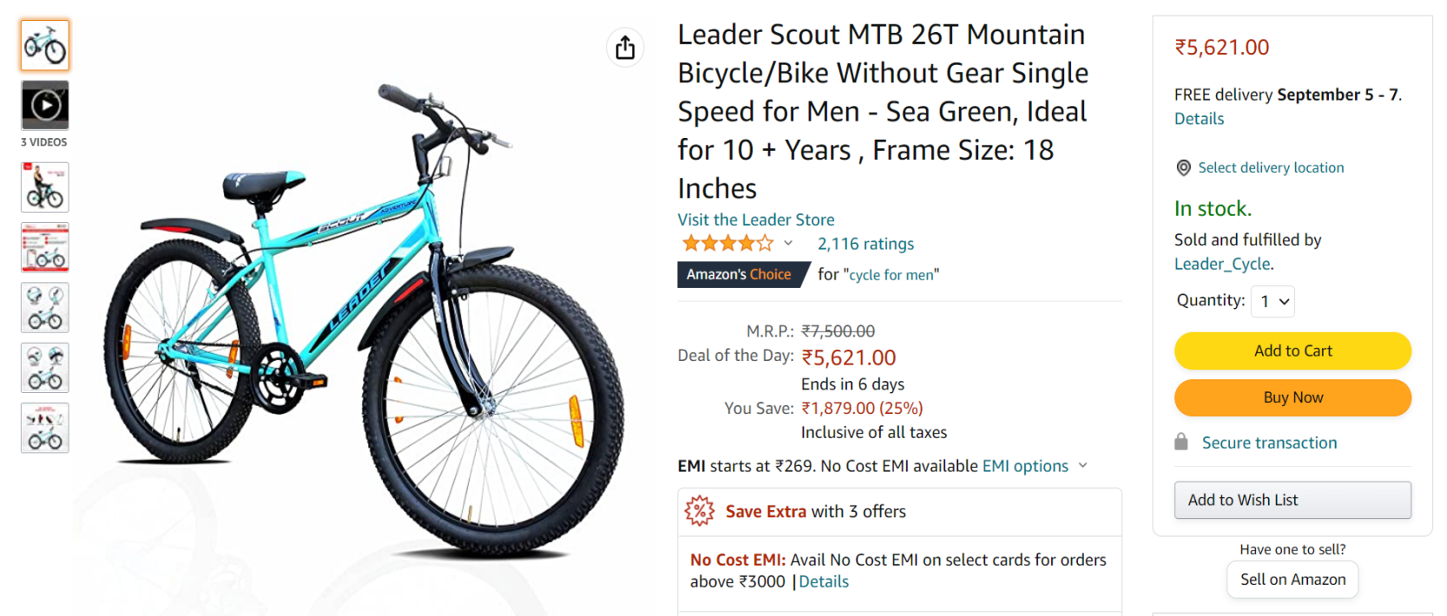

* **Name and cost of the product;**
* **Sliding Images of the product;**
* **Options: Add to Cart;**

**Buy Now;**

**Wish List**

* **Product information;**
* **Products related to this item;**
* **Customer questions & answers;**
* **Customer reviews**

1. **Payment Page //**

* **Select Address;**
* **Payment Methods: Debit/Credit/ATM card;**

**Net Banking;**

**Other UPI apps;**

**EMI options;**

**Pay on Delivery**